Project C Tables from SPSS Spring 2022
Project by Ivanou Ivan

Project Overview:
Run the following analyses:
1. Frequencies (Command in SPSS: Analyze→ Descriptive statistics → Frequencies, in charts box choose bar charts)
2. Cross-tabulation (Command: Analyze→ Descriptive statistics →Crosstabs)
3. T-test (Command: Analyze→Compare means → Independent samples t-test)
4. ANOVA (Command: Analyze→Compare means → One-Way ANOVA) Correlation (Command: Analyze→ Correlate →Bivariate)

Objectives:
- Frequencies
- Cross-tabulation
- T-test
- ANOVA

Requirements/Task(s):
Analyses via “IBM SPSS Statistics” to do:
Frequencies,
Cross-tabulation,
T-test,
ANOVA

Frequencies:

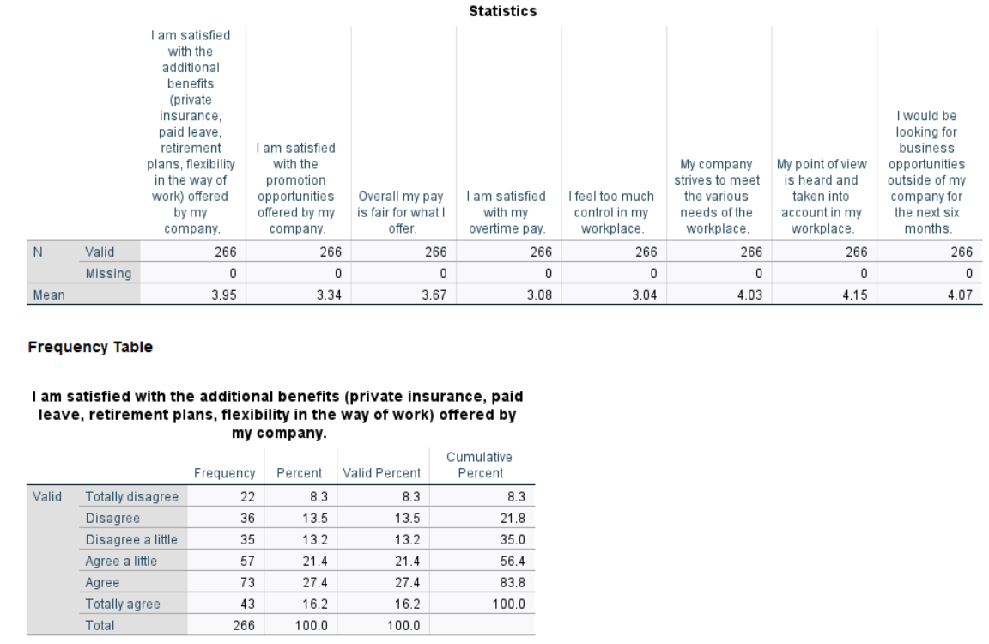

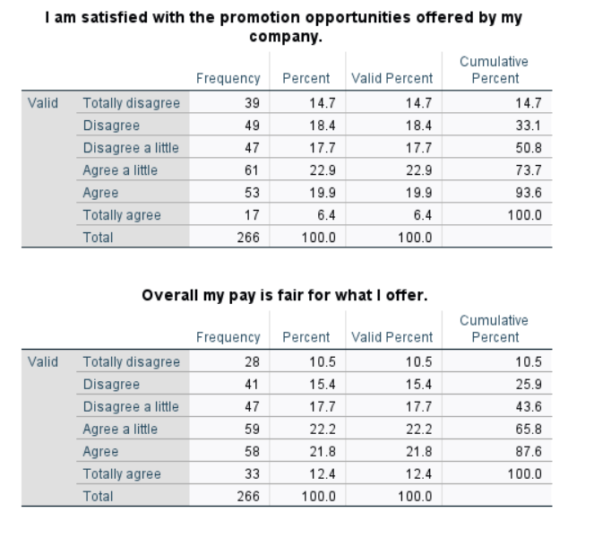

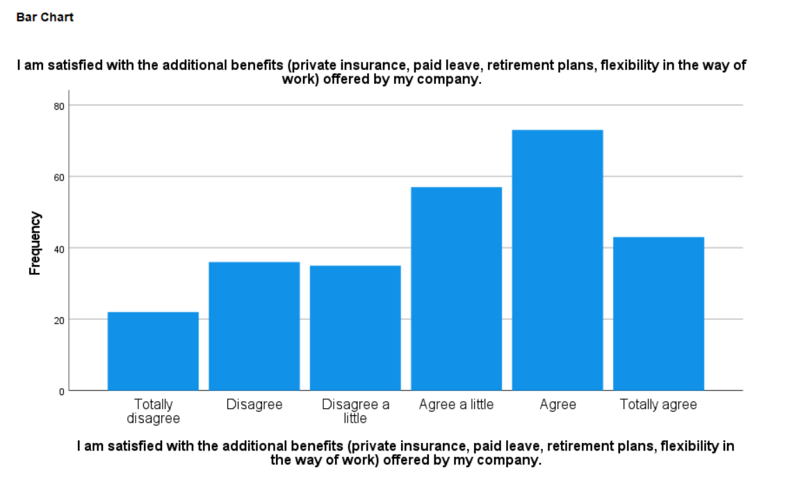

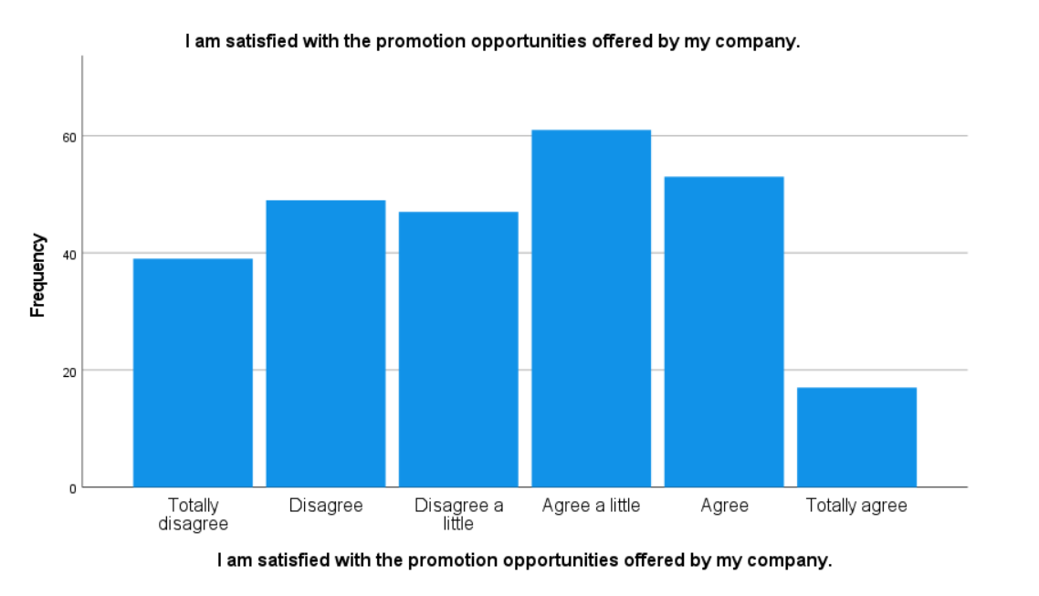

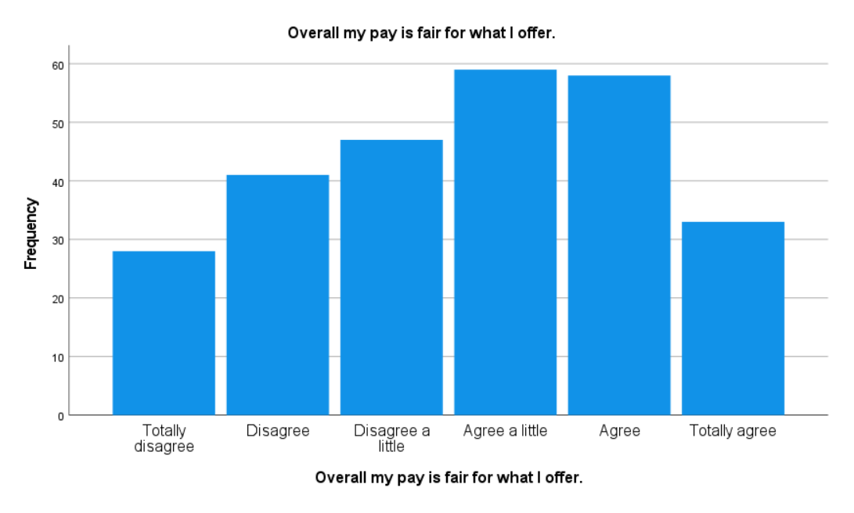

Q: Overall my pay is fair for what I offer

1. On % of people said that they’re: “Agree” (27.4%)

Second biggest % of people said that they’re: “Agree a little” (21.4%)

Then goes less than 20%:

Totally agree (16.2%)

Disagree (13.5%)

Disagree a little (13.2%)

Totally disagree (8.3%)

2. According to the statistics we have I can make a conclusion that highly likely most of the people who selected “Agree” select this answer just because they don’t want to be in a “conflict” or in a “trouble” with CEO and CTO after, cause this answer is a neutral answer.

“Totally disagree”, “Disagree” & “Disagree a little”, those people want to have a raise at the company where they are working.

“Totally agree” are those who are close to be promoted, team leaders or working on a position where company can’t find equal specialist for the same money.

3. As a recommendation I can give an advice that for those who selected: “Totally disagree”, “Disagree” & “Disagree a little” should make some decisions to make they salary higher, for other “groups” – no future raises

Q: I am satisfied with the promotion opportunities offered by my company

1. On % of people said that they’re: “Agree a little” (22.9%)

Second biggest % of people said that they’re: “Agree” (19.9%)

Then goes less than 20%:

Disagree (18.4%)

Disagree a little (17.7%)

Totally disagree (14.7%)

Totally agree (6.4%)

2. According to the statistics we have I can make a conclusion that on this issue, there is a big disagreement in this company since the division of percentages into agree and disagree is almost 50 to 50

3. As a recommendation I can give an advice that for those people who selected “Disagree”, “Disagree a little” & “Totally disagree” company should show that there is a good job opportunity where they can be promoted in this company. For other “groups” – no future changes/decisions

Q: I am satisfied with the additional benefits (private insurance, paid leave, retirement plans, flexibility in the way of work) offered by my company

1. On % of people said that they’re: “Agree a little” (22.2%)

Second biggest % of people said that they’re: “Agree” (21.8%)

Then goes less than 20%:

Disagree a little (17.7%)

Disagree (15.4%)

Totally agree (12.4%)

Totally disagree (10.5%)

2. According to the statistics we have I can make a conclusion that company shouldn’t make some “big future changes”. Company should show to the co-workers some small changes to turn their disagreement in to “Agree” or “Agree a little”

3. As a recommendation I can give an advice that this is not the weakest side of this company and it is worth focusing on other more important things for this company, but it is worth making small changes that will be indicative for the company's employees.

Cross-tabulation:

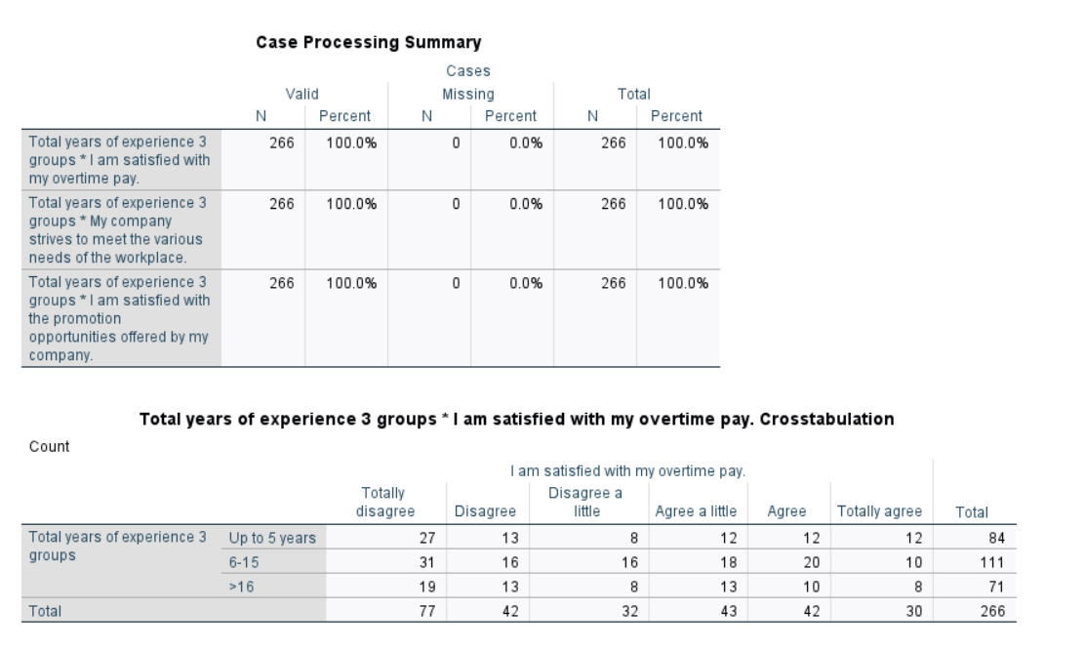

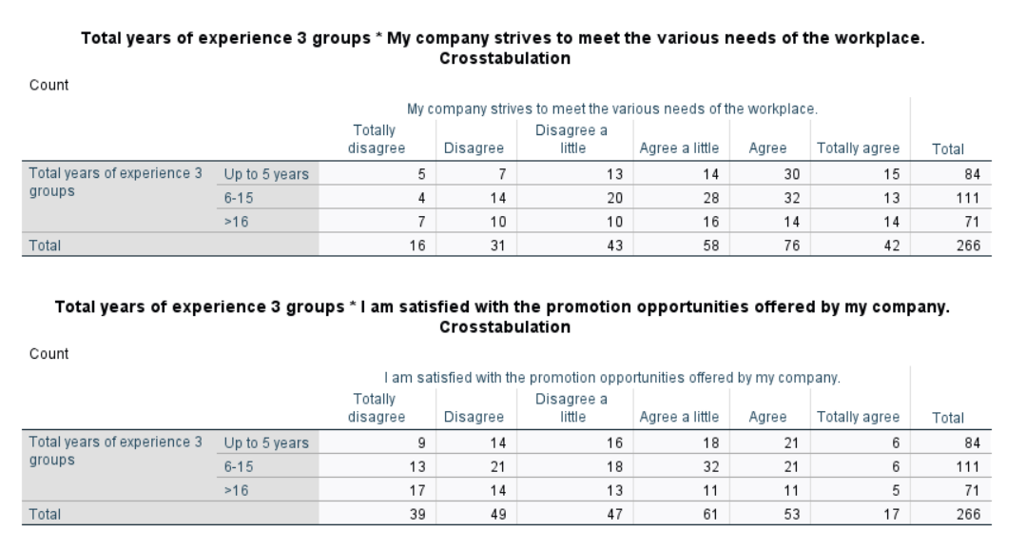

Q: Total years of experience 3 groups * My company to meet the various needs of the workplace

Total years of experience 3 groups (%):

Up to 5 years:

Agree (30%)

Totally agree (15%)

Agree a little (14%)

Disagree a little (13%)

Disagree (7%)

Totally disagree (5%)

6-15 years:

Agree (32%)

Totally agree (13%)

Agree a little (28%)

Disagree a little (20%)

Disagree (14%)

Totally disagree (4%)

>16 years:

Agree (14%)

Totally agree (14%)

Agree a little (16%)

Disagree a little (10%)

Disagree (10%)

Totally disagree (7%)

2. “Agree” between “Up to 5 years” and “6-15 years” are doesn’t so visible but compare to the “>16 years” the difference is ~2 times compare to previous results. Difference between “Totally agree” is not visible at all. “Agree a little” difference is visible because “Up to 5 years” is 14%, “6-15 years” is 28% & “>16 years” is 16%. “Disagree a little” difference is visible because “Up to 5 years” is 13%, “6-15 years” is 20% & “>16 years” is 10%. “Disagree” and “Totally disagree” is not so visible so by my opinion comparing is not needed.

3. The main difference in statistic is between “Up to 5 years” and “>16 years” and “6-15 years” is most often an intermediate value.

4. As a recommendation I can give an advice that company should do some actions in way to understand the opinion of all groups and make a summarized decision

Q: Total years of experience 3 groups * I am satisfied with the promotion opportunities offered by my company

1. Total years of experience 3 groups (%):

Up to 5 years:

Agree (21%)

Totally agree (6%)

Agree a little (18%)

Disagree a little (18%)

Disagree (14%)

Totally disagree (9%)

6-15 years:

Agree (21%)

Totally agree (6%)

Agree a little (32%)

Disagree a little (18%)

Disagree (21%)

Totally disagree (13%)

>16 years:

Agree (11%)

Totally agree (5%)

Agree a little (11%)

Disagree a little (13%)

Disagree (14%)

Totally disagree (17%)

2. “Agree” between “Up to 5 years” and “6-15 years” are doesn’t so visible but compare to the “>16 years” the difference is ~2 times compare to previous results. Difference between “Totally agree” is not visible at all. “Agree a little” difference is visible because “Up to 5 years” is 18%, “6-15 years” is 32% & “>16 years” is 11%. “Disagree a little” difference isn’t visible between “Up to 5 years” & “6-15 years” but “>16 years” different is 5%. “Disagree” between “Up to 5 years” and “>16 years” isn’t visible but the difference with “6-15 years” is 7%. “Totally disagree” different between “Up to 5 years” and “6-15 years” is 4% and “6-15 years” and “>16 years” different is 4%. The statistic of the last one growth exponentially by 4% each group.

3. The main difference in statistic is between 2 groups (“Up to 5 years” and “6-15 years”) and “>16 years”, cause “Up to 5 years” and “6-15 years” are close enough according to the statistic

4. As a recommendation I can give an advice that company should take care more about group “>16 years”, because the statistic between “Up to 5 years” and “6-15 years” are close enough

Q: Total years of experience 3 groups * I am satisfied with my overtime pay.

1. Total years of experience 3 groups (%):

Up to 5 years:

Agree (12%)

Totally agree (12%)

Agree a little (12%)

Disagree a little (8%)

Disagree (13%)

Totally disagree (27%)

6-15 years:

Agree (20%)

Totally agree (10%)

Agree a little (18%)

Disagree a little (16%)

Disagree (16%)

Totally disagree (31%)

>16 years:

Agree (10%)

Totally agree (8%)

Agree a little (13%)

Disagree a little (8%)

Disagree (13%)

Totally disagree (19%)

2. “Agree” between “Up to 5 years” and “>16 years” are doesn’t so visible but compare to the “6-15 years” the difference is ~2 times compare to previous results. Difference between “Totally agree” is 2% between all 3 groups. “Agree a little” difference is visible because “Up to 5 years” is 12%, “6-15 years” is 18% & “>16 years” is 13%. “Disagree a little” difference isn’t visible between “Up to 5 years” & “>16 years” but “6-15 years” different is 8%. “Disagree” isn’t visible. “Totally disagree” different between “Up to 5 years” and “6-15 years” is 4% and “6-15 years” and “>16 years” different is 12%.

3. The main difference in statistic is between 2 groups (“Up to 5 years” and “>16 years”) and “6-15 years”, cause “Up to 5 years” and “>16 years” are close enough according to the statistic

4. As a recommendation I can give an advice that company should take care more about group “6-15 years”, because the statistic between “Up to 5 years” and “>16 years” are close enough

T-test:

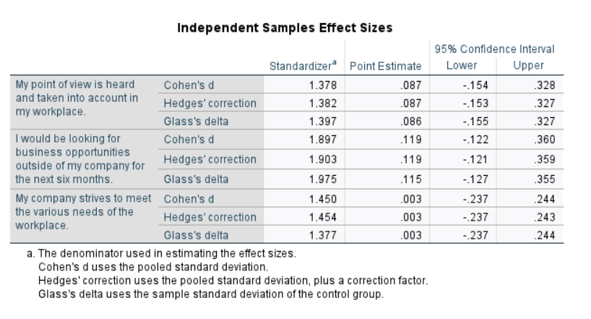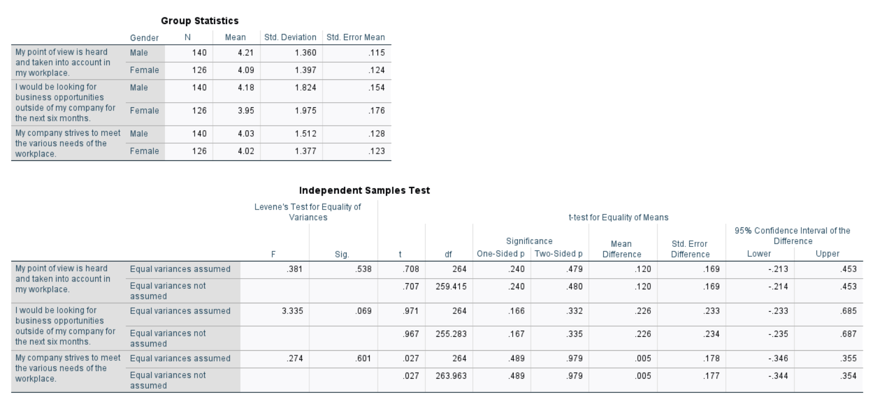

Q: My point of view is heard and taken into account in my workplace

The most average value is group “male”, however, the remaining group do not have much difference, which makes it clear to us that there is not much disagreement between the groups on this issue.

No, the differences are not statistically significant

The results make us understand that the group of men in this issue is more "weighty" in terms of the parameters: "H", "Mean", however, it lags behind in the parameters "Std. Deviation" and "Std Error Mean"

Due to the small amount of disagreement and relative stability on this issue, my recommendations would be small changes and possible more frequent contact and discussion of this issue between the two groups.

Q: I would be looking for business opportunities outside of my company for the next six months

The most average value is group “female”, however, the remaining group do not have much difference, which makes it clear to us that there is not much disagreement between the groups on this issue.

Difference is statistically significant between groups in columns: “Std. Deviation”, “Std. Error Mean” & “N” where the difference is stat. sign.

The results make us understand that the group of men in this issue is more "weighty" in terms of the parameters: "H", "Mean", however, it lags behind in the parameters "Std. Deviation" and "Std Error Mean"

In this matter, I could say that due to the statistically significant difference in the most of the columns, it would be worth making some changes to resolve this issue in the company

Q: My company strives to meet the various needs of the workplace

The most average value is group “male”, however, the remaining group do not have much difference, which makes it clear to us that there is not much disagreement between the groups on this issue.

Difference is statistically significant between groups in columns: “Std. Deviation” & “N” where the difference is stat. sign.

The results make us understand that the group of men in this issue is more "weighty" in terms of the parameters: "Std Error Mean", "Mean", however, it lags behind in the parameters "Std. Deviation" and "H"

Due to the small amount of disagreement and relative stability on this issue, my recommendations would be small changes and possible more frequent contact and discussion of this issue between the two groups.

ANOVA:

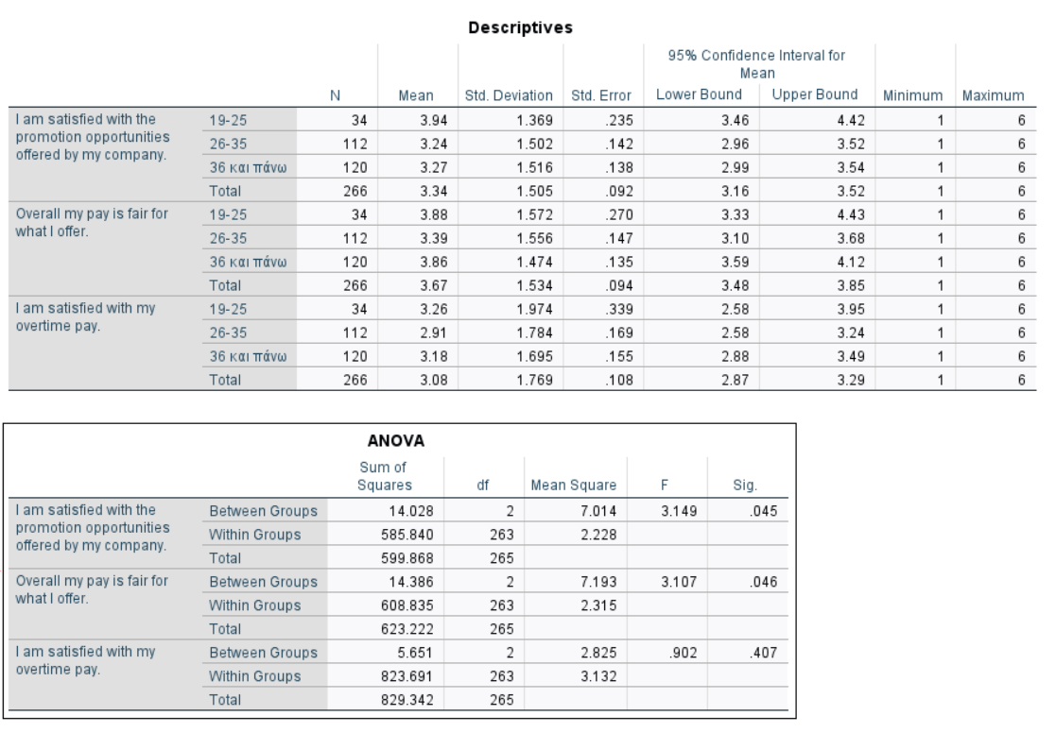

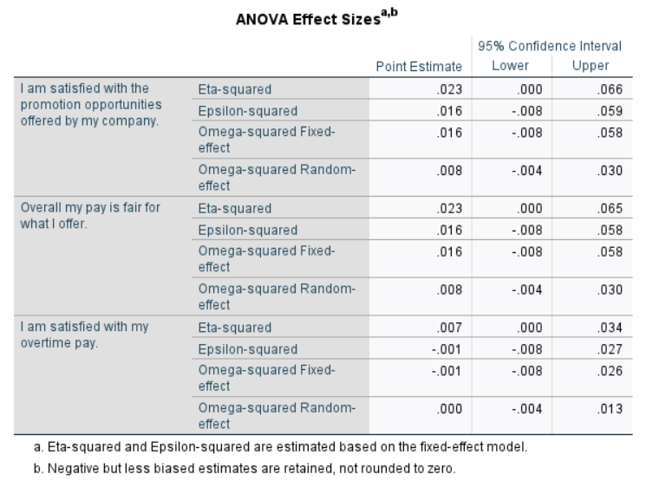

Q: I am satisfied with the promotion opportunities offered by my company

1. The highest “Mean” has group “19-25” & this group also has the highest “Std. Error” & “Lower Bound” and “Higher Bound”. Meanwhile this group has lowest amount at the “N” & “Std. Deviation” column. Groups “26-35” & “36 and above” doesn’t have so much visible differences on the table.

2. Difference “Between groups” isn’t visible compared to “Within groups” in a “sum of squares” meanwhile in “df” in “Between groups” we don’t see a lot of differences so we can say that the difference is not visible for now in this column, but if we will do the same analyst for a “Within groups” in “df” we could say that the difference is much more visible

3. The results can tell us that the main difference is between groups “19-25” because in groups “26-35” & “36 and above” we can see approximately the same results

4. My suggestion will be to give a shot and try to make group “19-25” more connected to groups “26-35” & “36 and above” because of a big difference

Q: I am satisfied with my overtime pay

1. The highest “Mean” has group “19-25” & this group also has the highest “Std. Error” and “Higher Bound”. Meanwhile this group has lowest amount at the “N” & “Std. Deviation” column. Groups “26-35” & “36 and above” doesn’t have so much visible differences on the table & group “36 and above” has the biggest amount in table in column “Lower Bound”.

2. Difference “Between groups” isn’t visible compared to “Within groups” in a “sum of squares” meanwhile in “df” in “Between groups” we don’t see a lot of differences so we can say that the difference is not visible for now in this column, but if we will do the same analyst for a “Within groups” in “df” we could say that the difference is much more visible

3. The results can tell us that the main difference is between groups “19-25” because in groups “26-35” & “36 and above” we can see approximately the same results, meanwhile group “36 and above” & “19-25” has only few approximately same results

4. My suggestion will be to work mostly with group “26-35”, because by the results this group doesn’t compare with other groups by the column-parameters

Q: Overall my pay is fair for what I offer

1. The highest “Mean” has group “19-25” & this group also has the highest “Std. Error” and “Higher Bound”, “N” & “Std. Deviation”. All the groups “19-25”, “26-35” and “36 and above” has the same results in the column “Lower Bound”

2. Difference “Between groups” isn’t visible compared to “Within groups” in a “sum of squares” meanwhile in “df” in “Between groups” we don’t see a lot of differences so we can say that the difference is not visible for now in this column, but if we will do the same analyst for a “Within groups” in “df” we could say that the difference is much more visible

3. In this question the group “19-25” has the highest results by all the following columns exclude “Lower Bound” where all groups have the same result

4. My suggestion will be to work mostly with groups “26-35” & “36 and above”, because by the results those groups has lowest indicators(exclude “Lower Bound”)

